1. Go to [http://aws.amazon.com](http://aws.amazon.com/)
2. Click on create free account button (Top right corner)

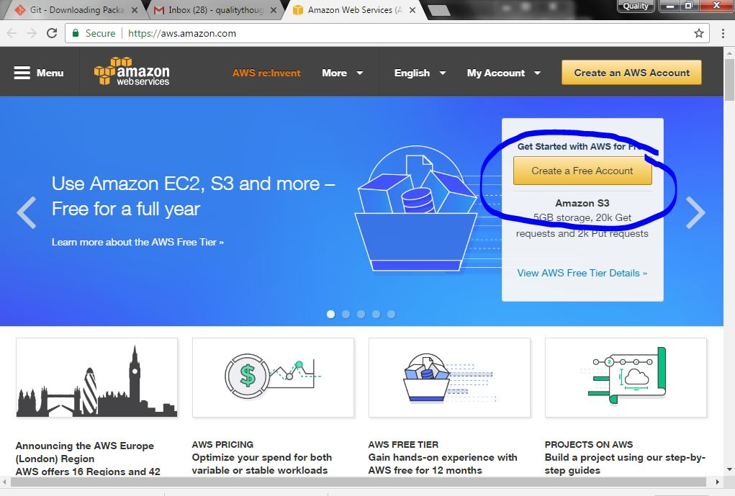

1. Select "I am new user" and sign up. It will ask your email id. click on sign in using our secure server button .

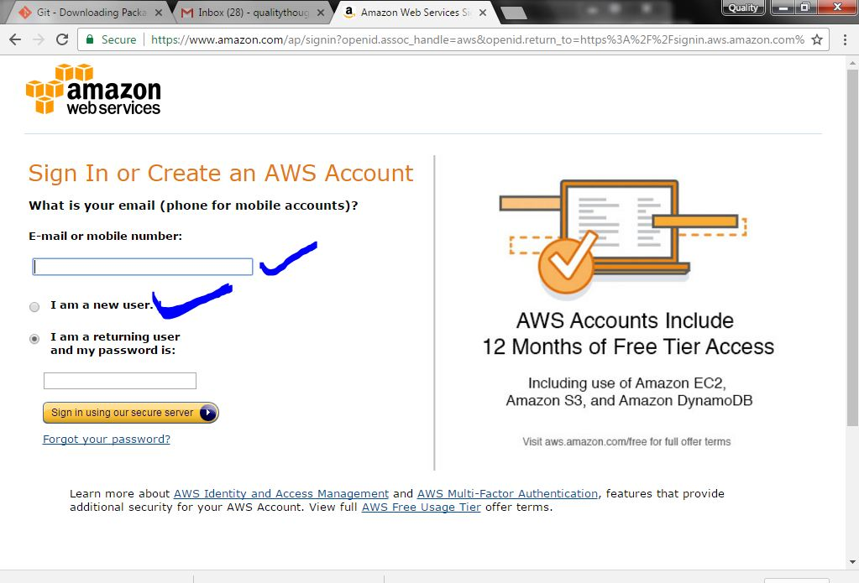

1. It will ask you some information like Name, email id, password. Click on create account.

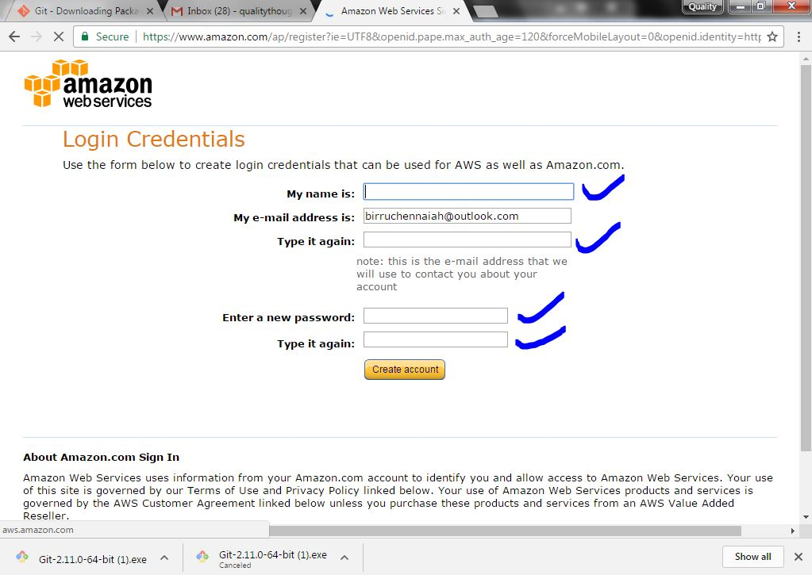

1. Now It will ask you to enter some more information like Name, Country, Address, Phone No, ZIP.

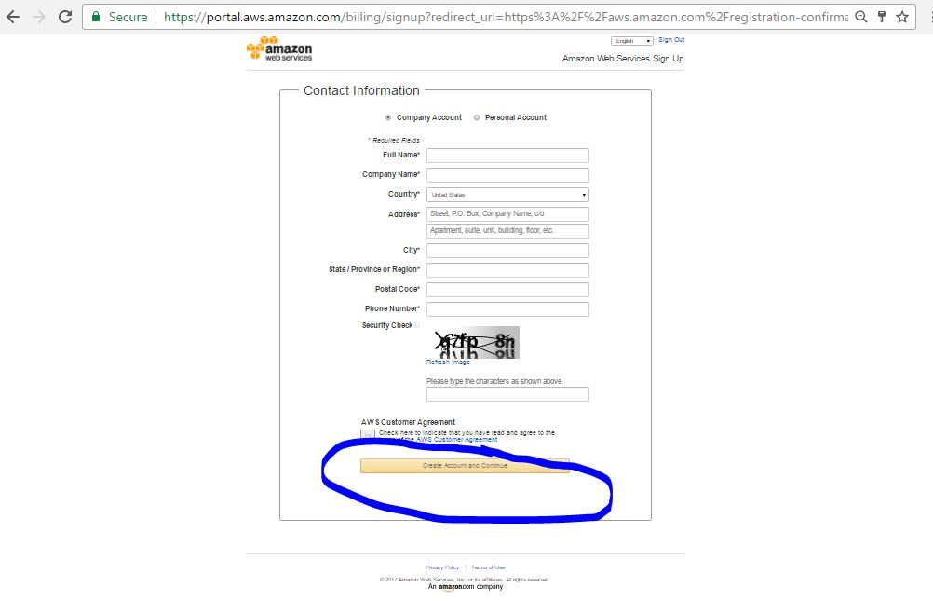

1. It will ask you for a valid credit card (You can use prepaid debit card also if you don't have credit card). unit amount will be deducted from your account.

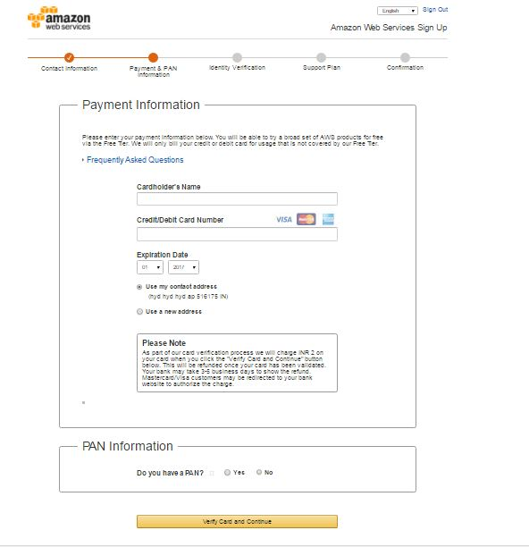

1. After that your phone no will be verified.
2. After phone verification you have successfully created your aws account. You have wait 24 hours for activation . (or) may be activated after 1 hour.

Now you can use any of the aws services based on your requirement.  
If you are a beginner you probably will be using EC2 instance.

Steps to create and use EC2 Instance.

1. Click on EC2 on the aws dashboard.
2. Click on "Launch Instance" button.
3. Select “Free tier only" bullet on the left side.
4. If you are using free tier you will have to use free instance like ubuntu 16.04 server or fedora etc. (beginner mostly use ubuntu 14.04 server).
5. Select instance from the list and choose 64 bit or 32 bit.
6. Click "**Choose Instance details**" on the right bottom corner.
7. Click "**add storage”** on the right bottom corner.
8. Click "**add tag”** on the right bottom corner.
9. Click "**configure security group”** on the right bottom corner.
10. Click "**review and launch”** on the right bottom corner.
11. Click “launch**”** on the right bottom corner.
12. Create new key-pair and download it.
13. After that you will get a window showing your instance details.
14. Click launch instances and few minutes later your instance will be ready to use.
15. Click on EC2 on the aws dashboard. And running instance.
16. You can connect your instance via ssh. Select the instance, right click, click connect and you you get a window showing command to connect from your local system via ssh.
17. Change security group details if you need.